“Even before He made the world, God loved us and chose us in Christ to be holy and without fault in His eyes. God decided in advance to adopt us into His own family by bringing us to Himself through Jesus Christ. This is what He wanted to do, and it gave Him great pleasure. So, we praise God for the glorious grace He has poured out on us who belong to His dear Son.”
Ephesians 1:4-6
READ: Ephesians 1:4-6

THINK: God loved you before you were even born. His love is everlasting and true. God picked YOU and He cares so much for YOU. God has brought YOU into his family. He wants to love and care for you forever. God doesn't offer His love because He has to, no, He wants too! His love is so deep for YOU.

PRAY: Everyone wants to be accepted. Sometimes you may feel lonely and just want someone to love you. God loves you so much and you are in his family. You belong in God’s family. Thank God for His love and acceptance and sing Him a song of praise for His great love.

LIVE: Now that you understand you have a role in God’s family, it is time to get started fulfilling your role!!! You have a mission to share His great love and acceptance to everyone around you. You can lead more people to know of God’s great love! You can include your friends at school, show God’s love even to those who have been unkind to you, and speak love into those who are hurting. God chose to love you before the world was created and He is so happy to have you in His family. Get up every day remembering that God accepts you for who you are and will always love you.

Sam MacLauchlan – GV Director

Though you have not seen him, you love him; and even though you do not see him now, you believe in him and are filled with an inexpressible and glorious joy.” 1 Peter 1:8

READ: Read Peter 1:8 once in a whisper and then again in a loud voice

THINK: God’s love requires faith, and faith is so much deeper than what we can see or understand. Faith gives feet to trust in what God has planned for our lives. Not being able to see God …not being able to witness Jesus’ miracles …doesn’t make Him any less real. Whether we believe or not, He is still in control of the universe, still sitting at the right hand of God, and loving us with a perfect love that we are incapable of understanding. The moment we accept Jesus He seals us as His and the Spirit dwells in us from that day forward. It’s a love that we don’t have to see, feel, or hear. It’s a love we know. A love we believe. A Cross we point to. Inexpressible. That accurately describes the feeling of being saved from ourselves and this world. Inexpressible.

PRAY: How do we thank Jesus for dying on the cross for us when He didn’t have to? For coming down from heaven to show us the way …and to make a way for us to be with Him? Kind of makes us feel …convicted

LIVE: Live today in confident faithfulness in Gods indescribable love for you.

Jairon Personius - Counselor

Whoever dwells in the shelter of the Most High will rest in the shadow of the Almighty.^{[a]}
I will say of the Lord, “He is my refuge and my fortress, my God, in whom I trust.”
Surely, he will save you from the fowler’s snare
and from the deadly pestilence. He will cover you with his feathers, and under his wings you will find refuge; his faithfulness will be your shield and rampart. You will not fear the terror of night, nor the arrow that flies by day, nor the pestilence that stalks in the darkness, nor the plague that destroys at midday. A thousand may fall at your side, ten thousand at your right hand, but it will not come near you. You will only observe with your eyes
and see the punishment of the wicked.
Psalms 91:1-8

READ: Psalm 91:1-8 with rhythm.
THINK: Imagine that you are heading out on a long journey. You have to leave your home, your family and everything you know behind. Along this road are many places where an ambush could happen. And yet, the place you are going to is so important that you would risk your life to get there. At night you record what’s is going on every day. That’s what Psalm 91 is. It tells of how God will be there to protect us.

PRAY: “I will say of the Lord, He is my refuge and my fortress. My God, in Him will I trust.” Pray that God will help you to trust Him. Pray that He will give you the strength to call Him your fortress.
LIVE: Each and every one of us has things to be afraid of. Someone that we love could get really sick, maybe we have to move to a new house and new friends, or maybe there is a really mean person at school. Each of these things are like the terrors described in Psalm 91. The cool thing about this passage is that God protects us through it all. We can abide or live in His presence. Even when bad things are all around us, we can trust God to take care of us.

Kristen Zolbrecht – Camp Office Manager

“O Lord, you have examined my heart
and know everything about me.
You know when I sit down or stand up.
You know my thoughts even when I’m far away.
You see me when I travel
and when I rest at home.
You know everything I do.
You know what I am going to say
even before I say it, Lord.
You go before me and follow me.
You place your hand of blessing on my head.
Such knowledge is too wonderful for me,
too great for me to understand!”

Psalms 139:1-6
(Extended version: Psalms 139:1-18)

READ: Read Psalm 139: 1-18, imagining you’re saying this to God.
THINK: These verses are a psalm of David, who had a life that was full of ups and downs. He grew up as a youngest brother, fought a giant with just a sling and a stone (and won), became the next to be in line for the kingdom (and later became king), and played and wrote music. He also ended up running for his life from his best friend’s dad (King Saul), hiding in caves and in foreign cities, leaving behind his family and friends. I often think that he may have lived a lonely life, wishing for someone who knew him, like really knew him and what he loved, what he disliked, what his passions were, why he did things and so on. But he wrote this song, realizing that God knew him, that God loved him, and that God was always with him no matter far away he went or how much he messed up. Have you ever felt like you didn’t have someone who really knew you? Think about what these verses say about how well God knows you and how much he loves you.
PRAY: Read this set of verses again as a prayer. Add your own prayer, remembering that God already knows you, so be honest with him, thank him, and allow him to be your friend.

LIVE: Knowing how good it feels to have someone who knows you, try to think of someone you can get to know better. Ask someone about themselves today, such as what they would love doing if they could do anything in the world, or another question that you would want to be asked.

Bethany Bradshaw – Program Director

“I pray that God, the source of hope, will fill you completely with joy and peace because you trust in him. Then you will overflow with confident hope through the power of the Holy Spirit.”
Romans 15:13

READ: Romans 15:13
“May the God of hope fill you with all joy and peace as you trust in him, so that you may overflow with hope by the power of the Holy Spirit.”
THINK: Trusting in something that I can’t physically feel is hard for me. This verse reminds me that if I do trust him that he will give me everything that I will ever need. Think about all the time he has given you more than you can imagine or a time God has given someone you know hope beyond what they asked. Trust is a hard thing to give for some people and trusting in something that is invisible is hard for people. Think of a time that if you would’ve had faith or trusted God that the outcome might have been different.
PRAY: Ask God to help you with building that trust you need to be overflowing with confidence in God. Ask Him to guide you through the process and your journey. Finish off by talking to Him like your best friend. To have trust you have to make that connection. Tell Him about your day, what went right or what went wrong.
LIVE: Reread the verse and this time add on verses 14-19 see what you can get from these verses and relate them to your own path and how it can help.‬‬‬‬

Brittany Fast - Waterfront

“Now may the Lord of peace himself give you his peace at all times and in every situation. The Lord be with you all.”
2 Thessalonians 3:16

READ: As you read this verse, think of times in your life that this could be relevant to and how, when applied to your life, your life could be different.
THINK: In this world and especially in today’s times, life can be very stressful and busy. Although this verse is not as common as other verses about peace, it is still very relevant. There is only one God, but He has many children. Sometimes, it can be hard to understand the idea that God can be with every single one of us all of the time. This verse helps show that God can be there for all of us and provide us with peace as we go about our lives. Whether the situation that you are in is good or bad, God can provide peace for whatever time you are in. How can this verse be applied to your life? In what ways do you think your life can be changed if you live this verse?
PRAY: Like this verse says, God can bring us peace in our lives when we ask. God is the only thing that can provide us with true and fulfilling peace. Take time to think about times in your life where you might have been stressed or worried, or think about stressful or worrisome times you are in now. Then take time to ask God to take the burden of those situations off of your shoulders to help you find peace.

LIVE: Knowing that God can provide you with peace that the earth cannot give, how do you think this can change your life for the better? Worry and stress tend to come with our earthly lives, and often it can be hard to maintain a healthy life with these things consuming so much. With God, He can help us find peace in the midst of hardship. With this knowledge, how does this affect your views on hardship and finding peace?

Ally Tyler- Mall assistant

The Lord says, “I will guide you along the best pathway for your life.
I will advise you and watch over you.
Psalms 32:8

READ: Psalm 32:8 carefully. Then read it two more times slowly.
THINK: This verse seems to be straight forward. However, life is crazy and it may seem that there are many paths that you can take. God can work with you on any path you choose. Many people stress about the future and careers. God can show his love and care through any career or passion.
PRAY: “Dear God, take control of my life today. Help me to make decisions that show your love to other people. Give me your wisdom in all that I do.” Pray that God will guide you in making wise decisions about your life. There is more than one path that you can take.
LIVE: Every day we make small choices that impact the lives of others. We can choose to show the love of Jesus through our actions. Try to be creative in the way you help others. Your journey with God is unique. Don’t compare it to other people’s journeys. God has given you talents and gifts. Use these gifts for the good of others and you will be on God’s path no matter where you go.
Abby Rodgers – Photography Instructor

But those who trust in the Lord will find new strength.
They will soar high on wings like eagles.
They will run and not grow weary.
They will walk and not faint.
Isaiah 40:31

READ: Read Isaiah 40:31 once quietly then once aloud
THINK: What is this verse saying to you, what is God putting on your heart or what is God relieving from your burden?

LIVE: Whenever you are doing anything just remember God is always there for you and you can always ask for help.

PRAY: Ask God to give you the strength to deal with whatever is thrown in your path.

Joshua Reynolds - Maintenance

“The Lord is my shepherd;
I have all that I need.
He lets me rest in green meadows;
he leads me beside peaceful streams.”
Psalms 23:1-2

READ: Psalms 23:1-2 Imagining yourself in a meadow and near a rippling creek

THINK: God takes care of us. He calls us children, His sons and daughters. He wants us to do more in life then just survive, He wants us to thrive! Think about what things you need God to help you with right now.

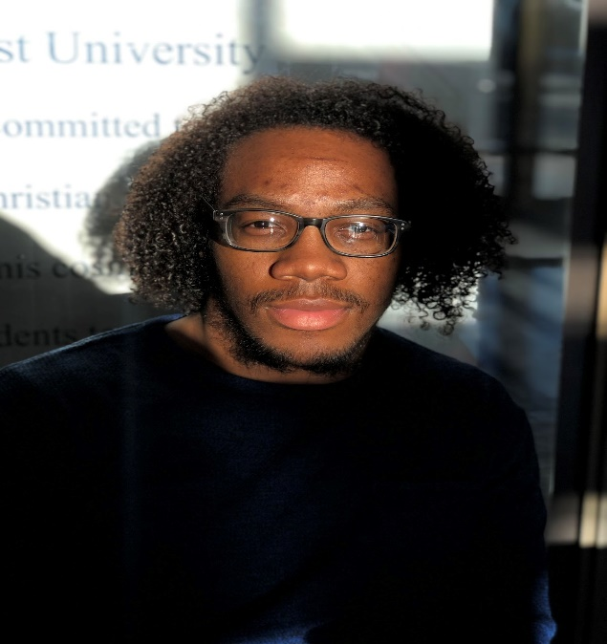
PRAY: Tell God of the things you need help with and then pray something like this: "God help me to realize that you are in control and are the one providing for the things I need. All of my needs are above me now, You handle them."

LIVE: Today follow God and recognize that He is the good shepherd and we are His sheep.

Maxwell Browne - Counselor

"The sun rises, and the sun sets, then it hurries back to rise again." Ecclesiastes 1:5

READ: Read Ecclesiastes 1:5 three times and remember to use this verse in a time when you’re struggling, or the world seems a little too crazy.

THINK: This verse reminds me that life will go on. No matter how dark a day may seem, time will pass, and a day will come again when the sun will shine. Remember that God is always there, day to day, he is always there, the son of love, even when you can't see the sun shining, just know that He has never left. He will be with you even in the darkest moments.

PRAY: Try this prayer: "Dear God, thank you for being the light of the world, a light through the darkness in my life. Please help me to remember that you are always there for me and love me more than I can even imagine. Help me to see the light on this dark earth, and to always look on the bright side, sharing your love and attitude wherever I go. Amen."

LIVE: Once you know that God is always with you, and His light floods your life, go and share this joy with others. Help them to find the light in the darkness, and when you feel God telling you those people are ready, share with them the true light, the light of the world.

Lindsay Rodgers – Gymnastics Instructor

Jesus grew in wisdom and in stature and in favor with God and all the people.
Luke 2:52

READ: Luke 2:52 four times in four different versions (the same version is OK if you don't have four versions).

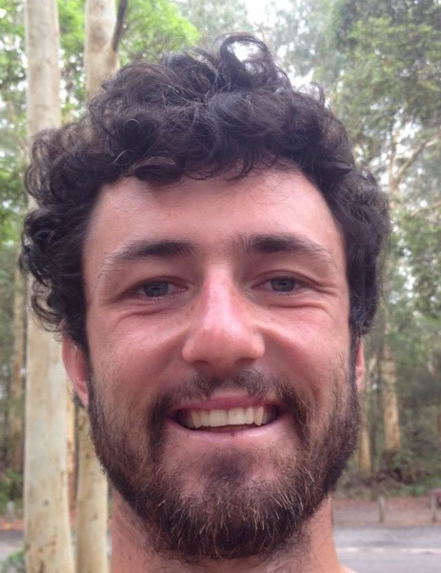
THINK: This is one of the few verses in the Bible that gives us insight into an important stage of Jesus's life. In the last story we're told before this He was only 12 years old, and the next thing we know He's beginning His ministry at age 30. It stands to reason then that this must be an important verse, and what Jesus got up to during this critical time of life should inform us as to what we should do during this time of our lives too. The Bible describes Jesus growing in four distinct areas of life - physical, mental, spiritual and social. These are all vitally important for growing into an all-round balanced human being. Just think - if you were the strongest person in the world, but didn't have the brains to know what to do with your strength, what good would that be? Or if you were the biggest social butterfly in the world, but lacked a relationship with God, what good would that be? To be flourishing, thriving human beings, we need to develop ourselves in all four areas. I like to summarize this verse to - 'He got strong, He got smart, He had friends and God was one of them.' Be like Jesus.

PRAY: Hey God, thank you for being a good God, and that we can trust you to always be there for us. Please help me to live a full life and grow in wisdom and in stature, in favor with God and man, just as Jesus did. Forgive me for the times I've neglected any of these areas in my life. Help me to encourage others to live their best life by growing in all four areas also. In Jesus's name, amen.

LIVE: Take out a piece of paper and divide it into four sections, one for each area. Think about the past week of your life and write down all the ways you've been working on each area. Which areas are you doing well in? Which areas could do with some more growth? Now, under each section write down how you are going to improve in each area this week. This could be going for a run three times in the week if you were low in the physical dimension; it could be spending half an hour each morning with God (like reading your Bible and/or writing to Him) if you needed more spiritual development; or making a study plan or learning something new if you need to work on your mental aspect. Share your plan with a friend or family member so they can check in with you and see how you're going with sticking to your plan and encourage them to live a flourishing life by developing themselves also.
Mitchell Lindbeck – Counselor

“If you need wisdom, ask our generous God, and he will give it to you. He will not rebuke you for asking. But when you ask him, be sure that your faith is in God alone. Do not waver, for a person with divided loyalty is as unsettled as a wave of the sea that is blown and tossed by the wind.
James 1:5-6”

READ: Read James 1:5 and think carefully about the many other promises God has given to us and how they affect our lives.
THINK: Promises are one of the most important aspects of the Bible. They exemplify just how marvelous and loving our God truly is. From the promise of coming again to the promise of lending knowledge to us: we can truly know that God will be there. I know personally that I doubt my decisions when they pertain to my life choices. On my own It would be impossible for me to make the correct decisions, but when I learn to have faith and trust in God I know he will bless me with the knowledge I need to make correct decisions.

PRAY: Claiming one of God's promises can be the most powerful thing we can do. They give us reason to whole heartedly humble our hearts and cling to the promises that God has given to us. While praying remember the blessing that knowledge can give us.

LIVE: Not knowing what decisions to make especially during this point in your lives is completely okay! Just remember to cling to God's promises and you will be blessed with the clarity needed to make even the most important decisions of your life.

Shawn Erick - Kitchen

“But those who hope in the Lord
will renew their strength.
They will soar on wings like eagles;
they will run and not grow weary,
they will walk and not be faint.”
Isaiah 40:31

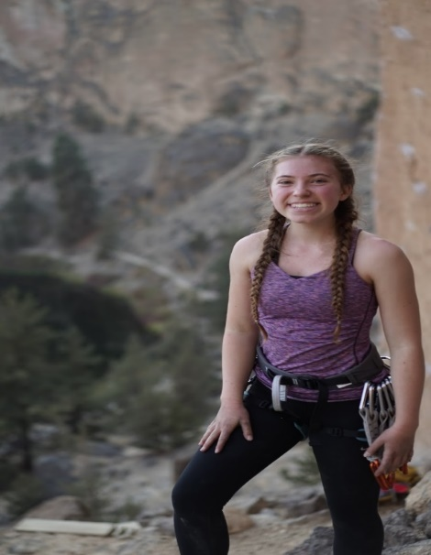
READ: Read the “Those” and “They” and replace your name with it
THINK: Think of it as God is talking to you and give you the strength to push through in life.
PRAY: Pray this verse asking God everyday if He can help you be strong in every circumstance and situation Trusting that He will give you just what you need, right when you need it.
LIVE: Trust that God will help you to be prepared and ready to face any hard and exhausting thing that comes your way.

Rachelle Bordeaux - Office

“For God is not unjust. He will not forget how hard you have worked for him and how you have shown your love to him by caring for other believers, as you still do.” Hebrews‬ 6:10‬ NLT‬‬
‬‬‬‬

READ: Read this verse with lots of energy
THINK: Think about the day you have had or are going to have. Remember to keep Jesus in your thoughts throughout the day and how much He served other people. Especially as you are doing tasks throughout the day, persevere and stay strong for God while serving his children. Remind yourself that God loves you and sees you doing His work with a happy heart and is thankful. Even if other people don’t notice you, God does.
PRAY: Pray for God to give you a hard-working heart and patience with others who you are working for and/or with.
LIVE: Don’t live a boring life! Choose to be intentional with helping others, don’t for something in return but because you can and want to share. God loves willing hearts that take opportunities to give back all the blessings He gives.

Emma MacLauchlan - Mall

O God, you are my God I earnestly search for you.
My soul thirsts for you; my whole-body longs for you in this parched and weary land where there is no water. I have seen you in your sanctuary
and gazed upon your power and glory.
Your unfailing love is better than life itself;
how I praise you! I will praise you as long as I live,
lifting up my hands to you in prayer.
You satisfy me more than the richest feast.
I will praise you with songs of joy. I lie awake thinking of you, meditating on you through the night. Because you are my helper,
I sing for joy in the shadow of your wings.
I cling to you; your strong right hand holds me securely. But those plotting to destroy me will come to ruin. They will go down into the depths of the earth. They will die by the sword
and become the food of jackals. But the king will rejoice in God. All who swear to tell the truth will praise him, while liars will be silenced.

Psalms 63

READ: Read Psalm 63 out loud

THINK: This is David’s song to God when he was in the wilderness of Judah. My favorite part from this passage is the first verse. When I read this verse it reminds me how much I long to know him better.

PRAYER: There is no better way to get to know God more than praying to him. Take some time to talk to God and to get to know him better.

LIVE: When verse 2 says “I have seen you in the sanctuary and beheld your power and your glory.” It reminds me of when I am in church praising the Lord and getting to know him more.

Skylar Yeager - Counselor

“And I am convinced that nothing can ever separate us from God’s love. Neither death nor life, neither angels nor demons, neither our fears for today nor our worries about tomorrow—not even the powers of hell can separate us from God’s love.”
Romans 8:38

READ: This verse is meant to be read with passion. Passion that NOTHING can ever separate us from God's love. It is a big deal, how much God loves us, no matter what may try to stop the love of Christ, it can never be hindered. This verse gives assurance and also peace.

THINK: The way that I think about this verse makes me want to cry. So many times, in our lives we are stressed or overloaded. Maybe something happened in our lives and we feel distant from God's presence, but even though we may feel separated, God's love will never be stopped. Christ gave his all, everything he had, and I mean EVERYTHING! We are given a wonderful peace once we realize the fullness and the extent that God would go for us.

PRAYER: Thank God for what he has given you and ask for strength to fear nothing and be able to endure anything. Pray for more thankfulness and to experience a peace that you have never felt before. God will give you strength and forgiveness if you just ask.

LIVE: Live your life through a new perspective. God has given you all of his love, and there is nothing that will ever stop it. Live in confidence and always live to the fullest, knowing that Jesus has saved you and there is nothing he wouldn't do for you.

Amanda Gerling - Office

“I lift up my eyes to the mountains—
where does my help come from?
My help comes from the Lord,
the Maker of heaven and earth.
He will not let your foot slip—
he who watches over you will not slumber;
indeed, he who watches over Israel
will neither slumber nor sleep.
The Lord watches over you—
the Lord is your shade at your right hand;
the sun will not harm you by day,
nor the moon by night.
The Lord will keep you from all harm—
he will watch over your life;
the Lord will watch over your coming and going
both now and forevermore.”
Psalms 121

READ: Read Psalm 121. As you read, try to think about King David’s life and what in his life might lead him to say this. If you don’t know the story of David, it can be found from the 16th chapter of 1st Samuel to the final chapter of 2nd Samuel.

THINK: The life of King David was filled with lots of difficult times. After he was chosen by God to be king, he spent years hiding from King Saul, his best friend’s dad, who wanted to kill him. After years of hiding and close encounters with death, David was finally able to become king because his best friend died in battle. But when he became king, the hard times didn’t stop. One of his sons killed one of his other sons and tried to steal his kingdom from him. These are only a few examples of the hard things that David had to deal with. But, if we read this Psalm, David is not complaining that these things happened. He is thanking and praising God for being with him. Even though King David went through some very hard times, God was always with him. David trusted God to help him overcome the struggles that he had to face. And because of God’s protection, David became the greatest king of Israel.

PRAY: If you want to pray this verse to God, you can read it out loud and think about what it means for your life as you do. Another thing that you can do is to listen to it in song form. There is a beautiful version of this verse (Requiem: Psalms 121) by Herbert Howells that you could listen to during your time with God. In addition to this, you can also thank God for watching over you in the past, right not, and in the future.

LIVE: This verse is calling you to stop worrying! When we remember that God is watching over us and cares for us daily, we don’t have to worry about what might happen to us. We just have to trust him to take care of us like he took care of King David.

Nate Cheney -Mountain Bike Instructor & A.M. Photographer

“Jesus came and told his disciples, “I have been given all authority in heaven and on earth. Therefore, go and make disciples of all the nations, baptizing them in the name of the Father and the Son and the Holy Spirit. Teach these new disciples to obey all the commands I have given you. And be sure of this: I am with you always, even to the end of the age.”
Matthew 28: 18-20

READ: Matthew 28:18-20 with enthusiasm
THINK: These couple verses highlight and sum up the ultimate mission of Jesus on Earth. In context, Jesus has just completed his life living as a part of humanity and is giving His disciples a final call and instruction before ascending to be with God the Father again. But what makes this closing passage of Matthew so special is that this call to go, to love, and to live for Jesus, is not only for those who physically walked with Him two thousand years ago... but it’s actually also for us! For every one of us living today. Right now. In this day and age.
PRAY: Going out into our day being intentional about how we are living for God and loving everyone we encounter can be draining at times. So it’s important to ask God every morning for a renewal of His Spirit and strength. And to ask Him to remind us that He always has been, always is, and always will be WITH us.
LIVE: One of the very key words in this text is “go”. It’s all too easy to live our lives sitting inside our comfort zone dropping Jesus’ name when it’s convenient or when someone steps into our safe bubble. But that’s not how we’re called to live. We’re called to GO! To MOVE! To LIVE OUT our love! And to be EXCITED! And Jesus is with us every step of the way... every single step.

Sydney Wolverton – Counselor
“Be of sober spirit, be on the alert. Your adversary, the devil, prowls around like a roaring lion, seeking someone to devour.”
1 Peter 5:8

READ: 1 Peter 5:8 twice slowly

THINK: I think of this as the number one rule, because it says above all. This verse shares how we need to be on alert. Try and think what it would look like to stay alert.
PRAY: I might pray that I might show everyone love and before I think about saying something mean, I try to love them.

LIVE: This can be called into action when someone does something and you think you should be aggressive towards them and you remember that you should love them over everything

Wils Haffner - Counselor

“A new commandment I give to you, that you love one another, even as I have loved you, that you also love one another.”
John 13:34

READ: John 13:34 (For more read Romans 8:38-39)

THINK: There is nothing that we can do that will stop God from loving us. It doesn't matter if I ignore God, insult him, get angry with him or even hate him! He loves me at my best and my worst. Amazing!!! Now Jesus asks us to love everybody just as much as God loves us. Wait what!? Jesus says we need to love everyone regardless of how they treat us.

PRAY: Loving people that are mean to us or loving people we don't even know sounds crazy! Why would you want to love someone that hurts you!? This sounds impossible! But Jesus promises us that with God anything is possible (Matthew 19:26). So, ask God to help you to love everyone, including those who do not like you! Pray for the people that hurt you. One of the most important lessons I have ever learned is that hurt people hurt other people. So pray for the people who hurt you because they are hurting too.

LIVE: So, what does loving other people look like? 1 Corinthians 13:4-7 describes love, "Love is patient and kind. Love is not jealous or boastful or proud or rude. It does not demand its own way. It is not irritable, and it keeps no record of being wronged. It does not rejoice about injustice but rejoices whenever the truth wins out. Love never gives up, never loses faith, is always hopeful, and endures through every circumstance."
Start practicing loving other people today by applying these principles to you everyday life.

Elyse McKay - Counselor

“In all circumstances take up the shield of faith, with which you can extinguish all the flaming darts of the evil one; and take the helmet of salvation, and the sword of the Spirit, which is the word of God”
Ephesians 6:16-17

READ: Read this verse as if you were a soldier.

THINK: God speaks to us directly through this verse and gives us three commands. First, He commands us to take a shield of faith. Second, He commands us to take the helmet of salvation. Lastly, He commands us to take up the sword of the Spirit. God also gives us clear reasons as to why we should follow His commands. There are going to be flaming darts from the evil one and many other things in this world that will cause us to need armor from God. God is telling us to take this armor He provides because He wants us safe. In what ways does He provide this protection?

PRAY: God is here to protect us and to love us, which is why He gave us His armor. This armor is readily accessible to us if we only ask God for it.

LIVE: How many times do we stop doing something we love because we are scared to fail? Or we don't live our life because we are scared of getting hurt?
The concept is the same as Capture the Flag. If you never play CTF because you are scared you will trip and hurt your knee, you will never get the chance to score for your team.
If you stop living for God because you are scared the Devil will hurt you, then you will never do God's works that He asked us to do.
Now if you reread the verse you can have the faith and the strength and the protection that God provides for us.

Emily Beaver – Assistant Girl’s Village Director

“For we know that our old self was crucified with him so that the body ruled by sin might be done away with, that we should no longer be slaves to sin”
Romans 6:6

READ: Read with an open mind and an open heart
THINK: This is a rather intriguing verse to me, it’s defiantly one that has come up in much conversation for many Christians. When I read this verse, I look at it in a such a way as to understand that the old me is gone and Christ has given me new life. Even when the old seems to show through he’s right there to make sure you can get back up and try again. And since he died on the cross already that new life and light is just waiting for you to say yes.

PRAY: Dear Jesus, help me to say yes to the life that you offer me and to want you with all my heart give me desire.

LIVE: I challenge you to memorize this verse and take it to heart. So that every time that you mess up you can go back to this promise that he made to us.

Jacob Welch - Maintenance

“God is our refuge and strength, a very present help in trouble. Therefore, we will not fear, though the earth should change and though the mountains slip into the heart of the sea; Though its waters roar and foam, though the mountains quake at its swelling pride.
There is a river whose streams make glad the city of God, the holy dwelling places of the Most High.
God is in the midst of her, she will not be moved;
God will help her when morning dawns.
The nations made an uproar, the kingdoms tottered; He raised His voice, the earth melted.
The Lord of hosts is with us; The God of Jacob is our stronghold.
Come, behold the works of the Lord,
Who has wrought desolations in the earth.
He makes wars to cease to the end of the earth;
He breaks the bow and cuts the spear in two;
He burns the chariots with fire.
“Cease striving and know that I am God;
I will be exalted among the nations, I will be exalted in the earth.” The Lord of hosts is with us; The God of Jacob is our stronghold.”
Psalms 46.
READ: Before you read, go outside and look up to the sky and think about how vast it is. Then imagine all the ups and downs of your life and the world. It's all vast and incredible right?

THINK: Psalm 46 is all about how troubled times may come, yet God is still in control. Pain might hurt, and wars may wage, but God ultimately is with us and is Lord over all. He is the victor.
Think about how every person goes through hard times, and that we are all in specific battles of our life. This should encourage us to have a bit more empathy toward one another.

PRAY: Pray for God to act in your life with the same reliability and steadiness that he shows in Psalm 46. Despite the craziness and chaos of life, he is still in control, and he calls us to be still and turn our eyes to him in hope and in trust.

LIVE: Go and live life with the reminder that God is Lord, and he cares for you and for me. The very earth may quake beneath our feet, yet he is ultimately in control. That's good news!

Jared Frost – Survival Instructor

“What, then, shall we say in response to these things? If God is for us, who can be against us?”
Romans 8:31

READ: Romans 8:31 (Extended 28-33)

THINK: Consider how some things that seem hard now may be teaching you something or helping you grow.
Reread verse 28. Even when we cannot find a ‘silver lining’, we can remember that God is working for good in our lives.

PRAY: We live in a fallen world, and our lives won’t always be free from trouble. However, as verses 31-32 tell us, God is always on our side. Talk with God about the struggles in your life and ask Him to give you peace and strength to get through them.

LIVE: With the knowledge that God is always working in your life, how can you approach bad circumstances differently?

Emily Nagele – Maintenance IT

“The Lord is with me; I will not be afraid.
What can mere mortals do to me?”
Psalms 118:6

READ: Psalm 118:6
THINK: Have you ever had a time in your life where the thought of facing something completely terrified you? In my life there have been countless times when fear has overcome me. The great thing about Psalm 118:6 is that it reminds us that with God by our side we can conquer anything. This life is filled with challenges that as humans we are not able to get through but the best thing about our Heavenly Father is that he can overcome anything in this world.
As our father his role and desire is to help us get through any of the challenges that we face.

PRAY: The best way we can get through these life obstacles is to ask for help. I encourage you to talk to God about your worries and struggles and seek comfort in him. Pray that He can give you the strength to surpass the big waves that try to hit you.

LIVE: knowing that God can indeed cast out fear I challenge you to let go of fear and let God have the control. Live out every day of your life boldly knowing that God can get you through anything and everything!

Yessenia Sanchez - Counselor

“My son do not forget my teaching,
but keep my commands in your heart,
for they will prolong your life many years
and bring you peace and prosperity.
Let love and faithfulness never leave you;
bind them around your neck,
write them on the tablet of your heart.
Then you will win favor and a good name
in the sight of God and man.
Trust in the Lord with all your heart
and lean not on your own understanding;
in all your ways submit to him,
and he will make your paths straight.”
Proverbs 3:1-6

READ: Read the passage, Proverbs 3:1-6.

THINK: Often it can be hard to ask for help from others. This text has been a helpful reminder to me to lean on God in times of need. The awesome thing is, God will always be there for you no matter what. In what ways can you lean on God and ask for help?

PRAY: Trust that God is listening and is capable to answer your prayers. Talk to Him about what you need help with and how He can support you while you lean on Him.

LIVE: Share with others what you have learned, how God has answered your prayers, and how He is someone you can learn to lean on. Read verses 1 and 2 again. Trust that following God's commands will lead to a happy and fulfilling life.

Emillie Hathaway - Counselor

“But those who trust in the Lord will find new strength. They will soar high on wings like eagles. They will run and not grow weary they will walk and not grow faint.”
Isaiah 40:31

READ: Isaiah 40:31

THINK: Think about what it would mean to have new strength. Not just strength the first time but to find more of it when you are feeling down or tired. This is God saying that if you put your trust in Him you will find something new, that you have never had before. Maybe a different type of strength.

PRAY: Take some time to pray for this strength maybe you really need it right now or maybe you need to keep going at something and you need to soar, run, and not get tired. Pray for whatever it is you need strength in.
LIVE: If you knew you had something extra you would be braver and more confident. What do you think you could do with a little extra strength?
Live like you have been giving that strength trust that God has given it to you

Alyssa Mayhew - Counselor

“You formed me in my mother’s body. I praise you because you made me in an amazing and wonderful way. What you have done is wonderful. I know this very well. You saw my bones being formed as I took shape in my mother’s body.
When I was put together there, you saw my body as it was formed.
All the days planned for me were written in your book before I was one day old.
God, your thoughts are precious to me. They are so many! If I could count them,
they would be more than all the grains of sand. When I wake up, I am still with you.”

Psalms 139:13-18

READ: Read the extended version of this passage: Psalms 139: 2-18

THINK: Think of the intricacies of your body. Think about the fact you can read without much thought, or that you don’t have to tell your heart to keep beating.

PRAY: We can thank Jesus for being with us no matter where we go or what we do. God is never going to leave us. If don’t feel like God is with us, we can pray that He will help us see where He is working in our lives. We can trust that God will protect us, loves us, and celebrates who we are. Thank God for going with you wherever you go and ask Him to help you follow Him. He created us and we can thank Him because we are fearfully and wonderfully made in His image! How cool!

LIVE: Live confidently knowing that God created us and knows we are full of many talents. Take time to use your talents to help and affirm the talents that God has given each of us. Your talent could be singing for others, fixing or building something, making food, making art to cheer someone up, or writing a letter

Emily Silcox - Counselor

“Come to Me, all you who labor and are heavy laden, and I will give you rest. Take My yoke upon you and learn from Me, for I am gentle and lowly in heart, and you will find rest for your souls. For My yoke is easy and My burden is light.”
Matthew‬ 11:28-30‬‬‬‬‬‬‬

READ: Read this passage and afterwards take a couple of deep breaths.

THINK: Life hardly ever goes as planned. So Jesus tells us up front that we can find rest in him. The more we practice being like him then when things don’t go the way we want or need we won’t worry as much. Jesus endured life filled with sadness, pain (physical, emotional, and spiritual), temptation, poverty, and just about anything you can think of that you’ve had to endure; yet His “yoke is easy, and His burden is light”. So, when life gets you down go to Jesus and lay your burdens at His feet so that your load won’t be so heavy. Continue to try to be more Like him so that you can have rest in your soul.

PRAY: To be more like Jesus and for God to give you internal peace/rest that the world can’t affect.

LIVE: There is no burden to small or to big for God to carry for you so you can turn to Him for everything. When life makes you feel sad, mad, frustrated, annoyed, etc. reread Matthew 11:28-30 to remind yourself that God wants to help, and you will find rest in Him.

Rachel Horton - Counselor

“No temptation has overtaken you except such as is common to man; but God is faithful, who will not allow you to be tempted beyond what you are able, but with the temptation will also make the way of escape, that you may be able to bear it.”
1 Corinthians 10:13

READ: Read this passage, carefully, putting emphasis on the ending

THINK: Think about how many times in your life there has been something that seemed overwhelming, or impossible to accomplish. Think about how God specifically says that there is nothing in your life that will be unbearable.

PRAY: Pray to God, talking about how amazing he is for giving you this strength, and the ability to push through any hard patch in your life. Pray about how we find out strength in God, and not in ourselves.

LIVE: Live fearlessly. Live like you can accomplish anything with the help of God. No matter how crazy something is, it can be done.

Hayden Roe - Maintenance

“Then Peter came to Jesus and asked, “Lord, how many times shall I forgive my brother or sister who sins against me? Up to seven times?”
Jesus answered, “I tell you, not seven times, but seventy-seven times.”
Matthew 18:21-22

READ: Read with expression the parable of the unforgiving servant - Matthew 18:21-35

THINK: when I first read this parable, I got really frustrated at the main character (let's call him Bob). Bob seems ridiculous!!! He has been forgiven millions of dollars (just imagine he has had ALL his school assignments cancelled). A MASSIVE burden on his shoulders would have been lifted! And then he goes and immediately gets angry at someone who owes him $5 - crazy!! But then it hits me... wow. We have been forgiven EVERYTHING we have ever done when we pray to Jesus and ask for it. This is a promise you can trust! But then we go and hold grudges against people and not forgive them. We are actually Bob in this story. What does God’s forgiveness mean for your life? Have you experienced forgiveness before?

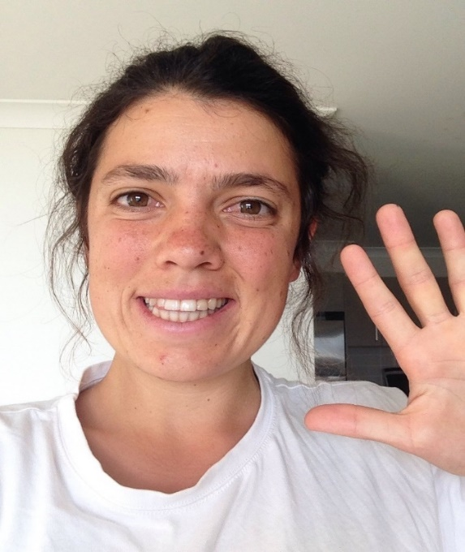
PRAY: God help us to remember that amazing love and forgiveness you have shown us. Help that fact to influence us and change our own hearts to be more forgiving to those around us.

LIVE: When I was in sixth grade, I told my cousin the secret that I liked Chris in my grade. Later that week, she confessed to me that she had told Chris. I was devastated and stormed away saying, "I will never forgive you!" Over the next hours I cried and was unsettled. I thought a lot about the whole thing and eventually felt guilty for not forgiving her. I walked next door to her room, and she was crying on her bed. I said that I could forgive her, and she was very sorry! I felt much better.
Is there a time you have found it hard to forgive someone? What things could help you make things right? Make a time to go and offer forgiveness or ask forgiveness of someone in person or through a letter.

Anna Beaden - Counselor

“But you are a chosen people, a royal priesthood, a holy nation, God’s special possession, that you may declare the praises of him who called you out of darkness into his wonderful light.”
1 Peter 2:9

READ: Read 1 Peter 2:9
THINK: This verse is a whole different level of special to me. It’s an encouragement, a promise, a message from God telling how important we are to Him and to His cause. So, to me, it is hope! Often, I struggle with understanding the apparent meaninglessness of everything around me. With some of the same questions that so many people struggle with: Why am I here? What am I supposed to do? Am I important? Even more so when the entire world seems to be conspiring against you! But these are questions that nobody can answer for us. Questions that make us uncomfortable. But this verse, although it doesn’t give us the straightforward answer we may be craving, gives us the assurance that He wants us, and that He needs us for His purpose of calling others out of the same darkness which we are constantly striving to walk away from. We may not know how, when, why, or even in what way, but we can now know and take comfort in knowing that it will happen, in God's perfect time.
PRAY: Take this moment to ask God into your heart, to ease whatever turmoil may be going on inside you. Ask Him to give you peace and surrender your future to Him, for Him to give you satisfaction in this promise, and for continued strength in your own walk, so that you may indeed show forth the praises of He who called you out of darkness and into His marvelous light.

LIVE: Renewed with God's new peace in your purpose and worth, share it with someone! Find someone who’s interested in your newfound mind-set and tell them about it. Not only will telling someone fortify your own beliefs in yourself, you may even lighten up a little piece of their “darkness.” And if you find yourself forgetful sometimes, read the verse again, write it down somewhere, memorize it. Whatever you need to do in order to keep yourself in that better state.

Ryan Spies - Wrangler

“If I speak in the tongues of men or of angels, but do not have love, I am only a resounding gong or a clanging cymbal. If I have the gift of prophecy and can fathom all mysteries and all knowledge, and if I have a faith that can move mountains, but do not have love, I am nothing. If I give all I possess to the poor and give over my body to hardship that I may boast, but do not have love, I gain nothing.”
1 Corinthians 13: 3

READ: I want you to read this verse to try and apply it to your own personal relationships with your friends, family or partner.

THINK: This verse is very personal for me. It’s true, that if there is no love, there is no need. With love, there is true intent and belief, and a desire to always work things out. With a friend, it doesn’t matter how often you say you are with them forever, or if you tell them to have faith, but you do not have love in your heart, it means nothing. Love is a glue that keeps promises and relationships. Love isn’t always for those special people in your life. Love can be all sorts of forms. Love can be for a sport, or it can be for a certain trail that you love to hike. Love teaches you to take care of the personal things in your life. Love is the most important thing in somebody’s life, because without love, life is worthless.

PRAY: As we pray, I would like you to ask God to show you His love. It is impossible for us to replicate God’s love, for his is eternal. But we came from Him, and he gave us the opportunity to love. Ask him how to truly love somebody, or something, so that that thing stays with you for eternity.

LIVE: I’ve been called into action to show the world how I love, and how I choose to show my love to others. Everybody shows love in different ways, and I want to challenge you to find how you love, show others, and challenge them to do the same.

Dylan Irvine – Sports Instructor

“The true light that gives light to everyone was coming into the world. He was in the world, and though the world was made through him, the world did not recognize him. He came to that which was his own, but his own did not receive him. Yet to all who did receive him, to those who believed in his name, he gave the right to become children of God— children born not of natural descent, nor of human decision or a husband’s will, but born of God.”
John 1:9-13

READ: Peruse John 1: 9-13, feel free to read it at whatever volume you want. Reread John 1:12 in case you blanked out for a sec

THINK: Imagine that you are God for a moment and think about how you would feel if your own creations didn’t recognize you. Maybe you would feel indignant, frustrated, hurt, or alone. Then imagine that you were the one who didn’t recognize Jesus. You might feel guilty or embarrassed, or maybe you don’t feel anything at all.
Finally, think about how God still wants to call you His child, regardless of where you come from or who you are, so long as you believe in Him.

PRAY: Praise God for being the light of the world, for coming down to save us even when we didn’t recognize Him, and for His love and mercy which He has for all people
If you can’t think of a prayer of your own, pray something like this: “Lord, thank you for coming into the world you created like a light into darkness! Thank you Jesus for loving me and for forgiving me even when I don’t recognize you in the world around me. Help me to eternally believe in you, to receive your word in my heart, and to claim your promise that everyone who believes in you is your beloved child! In your name I pray, amen.

LIVE: From now on, try to recognize and kindly receive everyone around you by getting to know them and being loving to them. Let other people know, whoever they are and wherever they come from, that they are loved and that all Jesus wants is for us to recognize and believe in Him.

Ben Griffin – Food Service

I will sing of steadfast love and justice; to you, O LORD, I will make music.

Psalms 101:1

READ: Read Psalms 101:1 and clap at the same time
THINK: I love that the Lord is so happy when we sing and make music as praise to Him. He puts music in is. Humans are musical from the time they are babies. Babies hear music and start nodding their heads in time to the music or start doing a little dance. Music is my way of praising God and also a way that God speaks to me.

PRAY: Dear Jesus, thank you for giving us a way to express ourselves through music. Speak words that You want me to hear. I want to praise you with my music.

LIVE: Listen to a worship song and listen carefully to the words. Is God speaking to you today?

Heidi Woodworth – Food Service Director

Blessed is the one
who does not walk in step with the wicked
or stand in the way that sinners take
or sit in the company of mockers,
but whose delight is in the law of the Lord,
and who meditates on his law day and night.
That person is like a tree planted by streams of water,
which yields its fruit in season
and whose leaf does not wither—
whatever they do prospers.
Psalm 1:1-3

READ: Read Psalm 1: 1-3 in a quiet space

THINK: Sometimes when life gets really busy it's hard to remember to invest time into a relationship with God. In all the business we can forget to make time to pray or read the Bible. The Clear Word version of the Bible starts Psalm 1 out by saying "happy is the man." I don't know about you but when I hear someone say they have the secret to happiness I usually tune in. The verse goes on to say that people who delight in God's law and meditate on his word daily will be happy.

PRAY: Even though reading the Bible can be a huge blessing sometimes it's hard to find the motivation to actually sit down and do it. What I've found is that praying for a desire to read God's word helps me want to read the Bible rather than seeing it as another thing on the checklist.

LIVE: I'd like to encourage you to give the Bible a chance. Choose a time in the day to dedicate to just spending time with him. When we spend time with our friends, we grow closer to them and it's the same way with God. He loved being with us and I believe that the Bible is one of the many ways that he speaks into our lives.

Amber Smith - Counselor

Do not love sleep or you will grow poor;
stay awake and you will have food to spare.
Proverbs 20:13

READ: Read this verse before school or work and keep it in the back of your head throughout the day.

THINK: Think of this verse as a reminder to keep yourself busy. Keep yourself busy with your passions, your friends, your family, and God. Putting your time towards these things are often more rewarding than sleeping in or doing nothing all day.

PRAY: When you pray this verse, ask God for balance and thank Him for the things that you love.

LIVE: After graduating from college, I am called to stay determined in my journey with the film industry. Relying faithfully in God, I believe I will still be able to thrive, even if my degree was useless.

Noah Paez – Food Service

Everyone was amazed and gave praise to God. They were filled with awe and said, “We have seen remarkable things today.”
Luke 5:26

READ: Luke 5:26 out loud

THINK: Think of something that was extremely amazing to you. Something that makes you really happy and or excited. Think to yourself, why was that amazing? What made that so special to me?
Now think of the most boring thing ever. Maybe something like an ant walking on the sidewalk. Or maybe a flower on an old rug. Think about something like this for 10 minutes even if you get distracted.
PRAY: Take time to think of boring things in life and BRING them to life. There are so many little details and fascinating things in everything around us. Pray to God to remind you that He gave us an unlimited number of amazing things that we take for granted every day.

LIVE: Think of something boring for 10 minutes everyday. Try to look at things in a new way, even if they seem insignificant or lame. By doing this, you’ll find your interest and respect in all things might change.

Tyrelle Massey – Kitchen

I will not die but live,
and will proclaim what the Lord has done.
Psalm 118:17

READ: Proclaim the verse Psalm 118:17.
THINK: Sometimes we get so caught up in life that we forget about the amazing things God has done for us. Think about the way you live your life. Are you living in fear? Or are you living as an example of Christ?
PRAY: Think about the times you have possibly taken God’s blessings for granted. Talk to God and find ways to thank him for the amazing things he’s done for you.
LIVE: Sometimes truly living for God is hard, especially when the world around you tells you that there’s no hope. When you run into a block in the road and are tempted to follow the way the world acts, remember what God has done in your life and the hope he has given to you. Take that feeling that share it with the world through your actions and words, because the Lord wants us to be full of life.

Chantel Personius – Art Instructor

Then the man said, “Your name will no longer be Jacob, but Israel, because you have struggled with God and with humans and have overcome.
Genesis 32:28

READ: Read Genesis 32:28

THINK: What does it mean to strive with God? What does it mean for God to give you a new identity?

PRAY: Pray that God will show you your true identity in him.

LIVE: Walk today in constant communication

ook, I am coming soon! My reward is with me, and I will give to each person according to what they have done.
Revelation 22:12

READ: Read Revelation 22:12-21, the last verses of the Bible.

THINK: There is a lot of stuff going on in our world: celebrity drama, injustice to fight, great causes to support, and our own lives to get together. When I look around at all the problems such as world hunger, poverty, human trafficking, global warming, and then I look at my own problems such as how am I going to get an A in my chemistry class, how do I make my parents happy, what do I want to do with my future, I can become overwhelmed by it all.

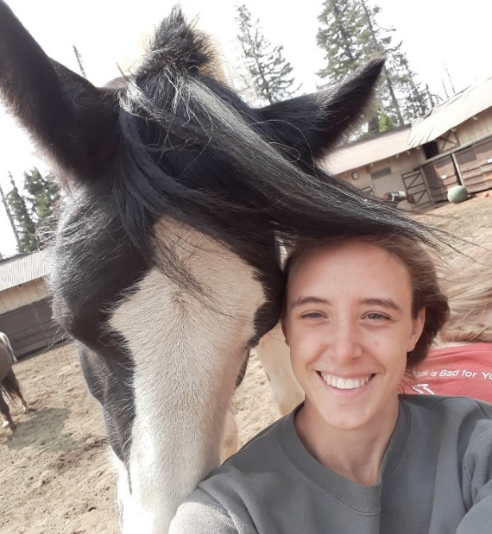
PRAY: When the world pulls me in almost every way, I find that the only safe and steady direction to look is up. I turn to these verses in the Bible and it reminds me what my true priority is: to live the rest of my life with Jesus in heaven.

LIVE: All those other problems that the world is telling you that you need to solve, all the tests and assignments looming up in front of you, all the arguments that never seem to end within your close family - they are only temporary. They are a small piece of our lives. Imagine millions of years from now, sitting with Jesus, feeling more loved than you ever have before - how much will that celebrity drama or spelling test matter? Even though we should do our best in everything we do, remember to get your priorities straight; what's going to matter years and years from now? God has an eternity planned for us and I can't wait!

Danielle Fullmer - Wrangler

Love is patient, love is kind. It does not envy, it does not boast, it is not proud. It does not dishonor others, it is not self-seeking, it is not easily angered, it keeps no record of wrongs. Love does not delight in evil but rejoices with the truth. It always protects, always trusts, always hopes, always perseveres.
1 Corinthians 13:4-7

READ: Read the passage, 1 Corinthians 13:4-7

THINK: For a lot of us, we read this passage and often connect it back to how we all have experienced love. But the love we have experienced is merely conditional. When God talks about love, it is referring to an unconditional love that we can’t begin to comprehend. Reading this passage, how does it speak into your life?

PRAY: When we look at our perspective of love, we are often afraid to come to God and confess the areas where we have made love selective in our lives. Take some time to not only confess, but also to give thanks and praise God for His unconditional love and forgiveness.

LIVE: In contrast to God’s unconditional love, how does this change your perspective on love? In what ways does this shift in perspective affect how you will connect with others? God’s love has no end and is forgiving beyond limits.
Reread verse 5. No matter the struggles you’ve faced or caused in your life, you are forgiven. God is love and we should model Him in how we love others.

Nic Pfieffer - Counselor

“Trust in the LORD and do good,
dwell in the land and enjoy good pasture.
Delight yourself in the LORD,
and He will give you the desires of your heart.”
Psalm 37: 3,4

READ: Read Psalm 37:3-4 in surrender
THINK: This summer I had an opportunity to hold a baby. Just not any baby, but a small baby of four months. And not just a little girl baby but a fussing little baby. Not just a fussing little child but one I had never meet before. She had never heard my voice or been held by me.
After receiving permission to hold her daughter, the mother watched as I picked up her child from the father. This little baby had her face puckered up, her cries starting to escalate and her arms and feet waving in frantic circles. As soon as I had her securely in my arms, I started talking to her. I calmly told her that it was perfectly alright to express herself. In fact, I told her to go ahead and let us know how she felt.
While still talking softly to her, I tried different positions against my chest. Within seconds she relaxed, stopped fussing and started looking around. I tried small bouncing motions and little sways back and forth, and she stayed calm and alert. Her eyes kept sweeping the room, taking everything in.
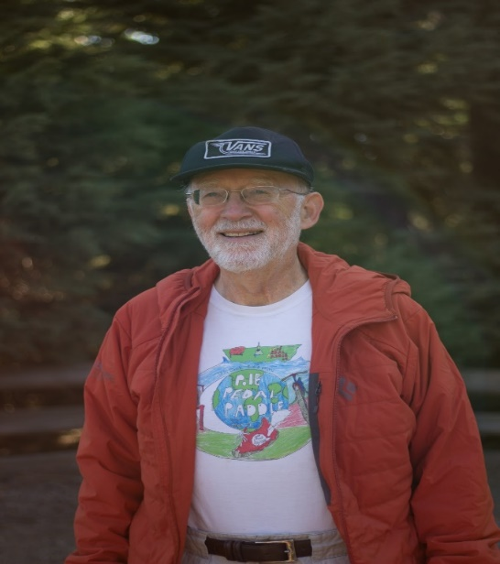
PRAY: Later that evening I prayed, “Father, may I trust in You, dwelling in Your Calming Presence. May I enjoy your company, and delight in You. This is the desire of my heart. This is all that I need. Amen. Try and pray this as well (close your eyes and imagine being lovingly held by God, listening to the delight in His Voice , as He tells you, “You are my favorite. I love you just as you are. Everything will be alright. I am never disappointed in you.)
LIVE: Live in peace trusting God to carry you in His arms
Daniel Tworog – Bus Driver Trainer

Peace I leave with you; my peace I give you. I do not give to you as the world gives. Do not let your hearts be troubled and do not be afraid.
John 14:27

READ: Read in the NIV and NLT
THINK: This verse is telling us that we don’t need to worry, because God has our backs, and he always has our backs. He doesn’t pick and choose when to give out peace, it’s constant and immeasurable.
PRAY: God, help me remember that you’ve always got my back, and because of that you give me peace. Thank you for that, Amen.
LIVE: God is calling us to not give each other peace like the world would, but how He would.

Nicholas Heinrich - Maintenance

“There are different kinds of spiritual gifts, but the same Spirit is the source of them all. There are different kinds of service, but we serve the same Lord. God works in different ways, but it is the same God who does the work in all of us. A spiritual gift is given to each of us so we can help each other.” 1 Corinthians 12:4-7

READ: Read while imagining what gifts you may have

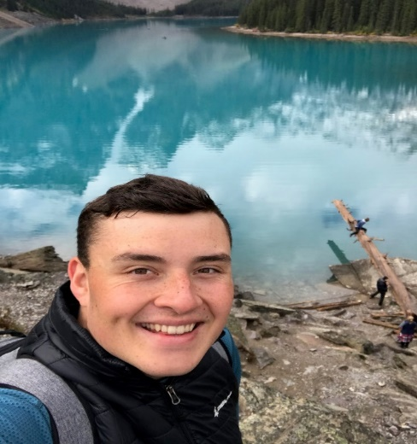
THINK: Each person has a spiritual gift that God has given to you. It could be something as simple as a patient heart to listen or maybe a musical gift so you can lead out in praise and worship. A spiritual gift from God is something that no one can take away from you and it’s been specially gifted to you!

PRAY: Sometimes it’s easy to get distracted by someone else’s spiritual gift. You may say to yourself “their gift is better than mine” or “why didn’t god bless me with that gift”. But our God never makes mistakes! He gave you a gift that will come in handy in just the right moment(s). Pray that he’ll guide you to the place or situation that will help your gift thrive!

LIVE: As it says in the verse: “God works in different ways, but it is the same God who does the work in all of us” if we try and work with one another to combine our spiritual gifts just imagine the possibilities god can achieve through us! Have a servant heart and go where god calls you and I promise that God will bless you and your gifts so that you can thrive!

Ethan Prowie - Waterfront

“Therefore, I tell you, do not worry about your life, what you will eat or drink; or about your body, what you will wear. Is not life more than food, and the body more than clothes?”
Matthew 6: 25-34
READ: Go sit somewhere outside where you can only hear the sounds of nature around you. read these verses slowly, staying aware of this beauty.

THINK: Think about the free-spirited nature of the natural world, especially during the different seasons. Leaves burst with color and float to the ground during fall. Snow blankets the earth, bringing out rosy cheeks and icy breath in the winter. Flowers bloom gracefully in the spring and the sun surrounds us with warmth and excitement throughout the summer. Nature does not worry about its transformation during the seasons. It does not resist the change; it simply gives in and lets the Creator do his work. Each season is beautiful & each season is necessary for the circle of life. Just as in nature, the Heavenly Father puts seasons in your life too. Some are full of light and joy, and others are full of darkness and confusion. Throughout all the seasons, our loving God knows what you need and is so excited to provide that for you. He adores all creatures, but you, beautiful child, are his favorite and he longs to prove that to you. He just wants you to trust in that promise and to ask him to be with you each & every day. Think about the different seasons of your life that you’ve experience lately. What are the ways in which you’ve seen God work? How might things have been different if you would’ve put your worries aside and trusted in him?

PRAY: I have found that the best way to get rid of my worries is to practice being thankful. Practice setting a habit of thanking Jesus throughout your day whenever something happy comes your way. Ask the Lord to open your eyes to the beauty around you so that your list of things you’re thankful for keeps getting longer and longer. Lastly, invite him to walk with you throughout your day and to bring peace and joy into your life.

LIVE: The best way to eliminate worry from your life is by remembering to let God be a part of it. Reread verse 6. What are the things that are keeping your from seeking God first? Take a chance and commit to giving those burdens to Jesus. I promise you; he will not disappoint you. Allow him to take your worries and replace them with joy.

Becky Valenzuela - Counselor

“I have told you these things so that in me you may have peace.
In this world you will have trouble.
But take heart!
I have overcome the world.”
John 16:33

READ: John 16:33 in a quiet space three times through and meditate on the words of Jesus Christ.

THINK: Throughout your life you will face many trials. I know that does not sound very encouraging, but that is just how living in a sinful word is. What is encouraging though is the truth that through all of our struggles God is there walking through the fire with us. We don’t need to be afraid about what the future holds because God is always holding us. We are never alone.
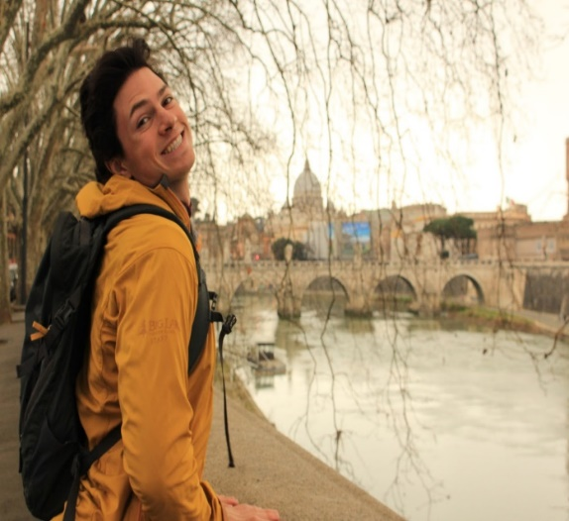
PRAY: Kneel and ask God to give you the courage to live a life of servitude. Speak with God. The more you talk with God the more you will hear him answer. As you get to know God better you will trust him more and you will be able to live a life of bravery.
LIVE: Go out in your daily life without fear. Be confident in your journey with others and with Christ. Be bold in how you serve your community because you know that God will lift you up even higher whenever you are working for the good of others.

Apollo Lizzi – Waterfront Director

“Shortly before dawn Jesus went out to them, walking on the lake. When the disciples saw him walking on the lake, they were terrified. “It’s a ghost,” they said, and cried out in fear.
But Jesus immediately said to them: “Take courage! It is I. Don’t be afraid.”
“Lord, if it’s you,” Peter replied, “tell me to come to you on the water.”
“Come,” he said.
Then Peter got down out of the boat, walked on the water and came toward Jesus. But when he saw the wind, he was afraid and, beginning to sink, cried out, “Lord, save me!”
³¹ Immediately Jesus reached out his hand and caught him. “You of little faith,” he said, “why did you doubt?”
Matthew 14: 25:31

READ: Read the passage Matthew 14:25-31 in your Bible carefully.

THINK: This is one of the bible stories we grew up with listening to, but there is so much more meaning to the words you just read than Jesus walking on water. Notice that the disciples were already frightened by the storm, so when Jesus comes to them on the water they become afraid as if he is a ghost. But Peter quickly realizes that it is Jesus, hops over the side and walks out to meet Jesus on the water. We then learn that only because of Peters wavering faith in that moment that he begins to sink. However when we cry out for help Jesus is right there to pick us back up. Have you ever lost your faith like Peter did?

PRAY: It is easy to fill our lives and minds with distractions from God and the way he has prepared for us. In those moments when we are separated from God our faith can waver and fall. When we feel distant from God it is dangerously easy to continue falling as guilt and sin creep in and take over. Ask God to come back into your life and guide your heart, mind and actions, confess your shortcomings and ask for Gods overwhelming forgiveness in your life.

LIVE: Think back to the last time you lost sight of God in your life, how did you feel when you realized you were sinking? Did you change the way you live your life to avoid another sinking ship? Read verse 33, how many times have you fallen on your knees to worship God after he has pulled you up out of the storm? Next time in a short prayer acknowledge that he truly is the Son of God.

Tobi Lizzi – Sailing Instructor

“The expert in the law replied, “The one who had mercy on him.”
Jesus told him, “Go and do likewise.”
Luke 10:25

READ: Read Luke 10:25-37 slowly and out loud.

THINK: Based on this passage, if living forever is only made possible by loving my neighbor, then it is crucial that I answer two questions: 1) Who is my neighbor? And, 2) how do I love them? To answer the first question, Jesus tells a parable to illustrate just who a “neighbor” is since the original meaning is unclear (“neighbor” could refer to a “companion,” “relative,” or “friend”). However, after hearing the parable, what does the lawyer discover about who a neighbor is? (Read Jesus’ question and the lawyers response again in verses 36 and 37). The lawyer discovers that your neighbor is whoever you are a neighbor to. In other words, anyone could be your neighbor if you treat them as such. The Samaritan was the neighbor to the wounded traveler. But why does Jesus choose a Samaritan to illustrate who a nieghbor is? Just a few verses ago in Luke 9:51-53, Jesus and his disciples are rejected by a Samaritan community! So, why would he make a Samaritan a hero of the story? Believe it or not, Jesus is drawing from a story in the Hebrew Bible when the Samaritans actually treated the Israelites with kindness! Check out the similarities between 2 Chonicles 28:1-15 (especially verse 15!) and Luke 10:30-35. Jesus chooses the Samaritan, then, to illustrate that even those who once treated you harshly are also your neighbor, especially when they turn and treat you with kindness.

PRAY: Pray about the final question, “how do I be a neighbor to someone?”
A rabbi known as Hillel the Elder who lived about a hundred years before Jesus was once asked to summarize all of God’s instructions in the Bible. And do you know what he said? “That which is hateful to you, do not do to your fellow.” Jesus makes a similar statement in Matthew 7:12 saying, “In everything, therefore, treat people the same way you want them to treat you, for this is the Law and the Prophets.”

LIVE: Make a list of all the things that irritate you (screaming, stealing, lying, smacking food, etc.). Also, throughout your day, take a mental or physical note of things that annoy you. Then, consider how you can make sure not to do these things to someone else. Next, make a list of all the treatments you enjoy (kind words, gifts, a hug, spending time with someone, acts of service,
etc.), and consider how you can treat someone how you would like to be treated. As 16th century Rabbi Moses Cordovero once said, “In everyone there is something of his fellow man...Hence, ‘love your neighbor’—for he is really you yourself.”

Bezi Lizzi - Counselor

“Therefore, I tell you, do not worry about your life, what you will eat or drink; or about your body, what you will wear. Is not life more than food, and the body more than clothes?”
Matthew 6:25-34

READ: Matthew 6:25-34

THINK: These verses in Matthew speak about our tendency to worry about our lives. This is a human reaction when times get tough and we do not know what to do. We often worry about how the next day of life may play out or our family or how we will get through a particular struggle. Verse 25 reminds us not worry about our lives, what we will eat, what we will drink, or even what we will wear. The writer relates this to the birds of the air. We are reminded in this passage that God keeps after the birds of the air and they neither sow nor weep. God knows about every piece of His creation and he knows the hairs on our heads. If he can protect and look after the birds of the air, he can surely keep after us in our time of struggle.

PRAY: Sometimes even as we read these verses, we still struggle with worries in our hearts. As we think about these words, let’s pray that God will help us to believe in His promises and that he always has our best interest at heart. In this world we will have trouble, but this our reminder that we do not have to worry. These verses also remind us to look at our task in the present moment rather than worrying about the future.

LIVE: As you go about your day today, how do these verses change the way that you will live your life today? As it says in verse 31, “So do not worry, saying, ‘What shall we eat?’ or ‘What shall we drink?’ or ‘What shall we wear?” The Bible reminds us that our heavenly father knows that we need these things. He will also be for us and by our side in the midst of our worries. As we move forward in life, we can have peace through the worries in life knowing that God has our best interest in mind. Anxieties may be present, but the encouragement that we receive in these verses remind us of his unfailing love for us and the encouragement we receive as a result.

Shannon Hill – Headquarters Director

